Working in the Cloud

with ClearMedia Academy

ClearMedia Triple Setup

**Disclaimer**:

By using the ClearMedia vCloud Director templates, you can greatly reduce the amount of time needed to deploy new VMs. These templates have been configured with the best practices in mind, to assure optimal stability and performance. Although use of the template is not compulsory, it is recommended!

On this first page you can find a small overview of the required steps. It is intended for engineers that already have experience with the ClearMedia vCloud Director and previous ClearMedia templates. The larger, more in-depth explanation with screenshots, can be found further on. It can be used by people without any prior knowledge if the overview is not clear or if it has been a while since your last deployment.

Quick steps

This guide assumes you are building a new vApp and deploying the template from the “Catalog” tab with a triple server setup. Connecting the new vApp to the internet is covered in other documents.

* Do not use the steps below if you do not know how to start. Go to the In-Depth steps instead.
* Select the tab “vApp Templates, right-click on the “Win2016 1.5” template and choose “Add to My Cloud”.
* Run through the first step of the wizard, give the new vApp a name and click “Finish”
* Ad the first VM to the vApp, which is the AD server. Configure it and boot it up.
* Log-on to the server, navigate to the folder C:\iNSTALL\ , right click on “SyncGit.ps1” and choose “Run with powershell” to sync with the GitHub repo.
* Now navigate to the folder C:\iNSTALL\deployment\TripleSetup\ , run the “CreateCMscript.ps1” script on the server by right clicking on it and choose “Run with PowerShell”.
* Answer the questions of the script, run the 2 AD scripts and let the server reboot itself.
* Now deploy 2 extra servers to the vApp, for the RDS and FS roles.
* Configure the Guest Customisation to join the servers to the new AD. Now start up the servers.
* Run the RDS script, that you can find on the AD server, on the RDS server.
* Install O365 and F-Secure on the servers.
* Disable all Guest Customisation options and configure the vApp Boot settings.
* Finished!

In-Depth explanation and step-by-step procedures

* Ask ClearMedia for extra resources via ticket, referring to a newly created quote.
* Check if you have enough resources via the “Administration” tab, under subtab “Monitor”.
* Contact ClearMedia if there are not enough resources.

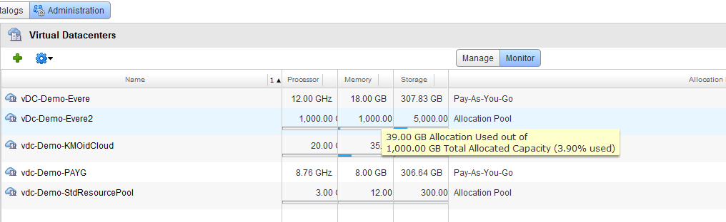

* Go to the Catalogs tab and navigate to the “vApp Templates” tab of the “Public Catalogs”.

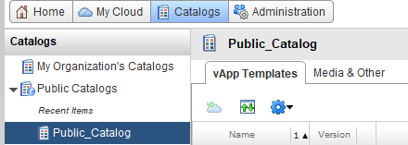

* On the right side, under “Customize Columns”, check the box for “Description” to see extra information about the templates.

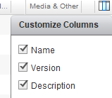

* Right-click on the Windows2016 1.5 template and choose “Add to My Cloud”.

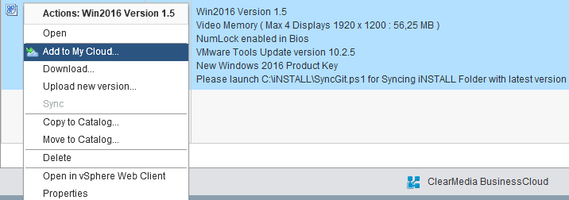

* Run through the steps of the wizard: (vApp name, description, location, storage, network).
* Use the end customer name as used in the contract, preceded by “vApp_”.
* Select the VDC, based on available resources (see step 2). If you do not have enough resources, please Contact ClearMedia Support.
* You do not need to change anything on the other tabs. Just click on “Finish” to deploy the template. We will edit the rest later.

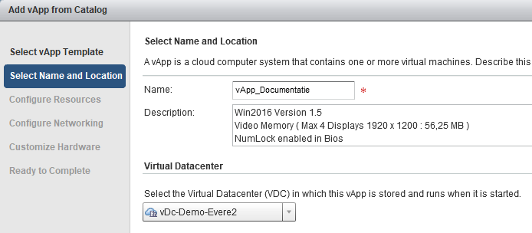

* Go to “My Cloud”. You can see the progress of the deployment here

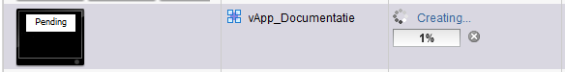

* It will take at least 20 minutes per VM to deploy.
* Now edit the new VM. Right click on it and at the bottom, click on Properties
  + On the “General tab”, change the Virtual Machine name and Computer name starting with “<Customername>-DC“
  + Do not change the Operating System tag! Never use “Server 2016” as the OS type, since this does not work.
  + Note that the tick boxes “Virtual CPU Hot add” and “Memory Hot add” are enabled.

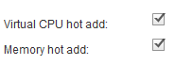

* + On the “Hardware tab”, keep the default resources. Do not change anything.
  + Also do do not change any network settings. They will be addressed later on.
  + At the network adapters, check the option “Show network adapter type” and verify you are using a “VMXNET 3” adapter with Windows VM.

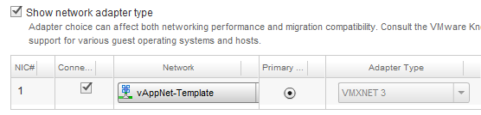

* + On the “Guest OS Customisation” tab, choose a complex password with a minimum 7 characters, 1 special character, and 1 number. Otherwise Windows will not accept it during Guest Customisation and logging on to the system will fail.
* Power on the VM. If this is the first time, wait at least 5 minutes for powering on and guest customisation to run successfully. It should finish with an automatic reboot.
* Open the Virtual Machine console based on the “How-To 0 VM Console” document.
* To verify that the Guest Customisation process ran successfully, logon with the new administrator credentials. If the new credentials work to log in, it ran successfully.
* Then turn the VM off again using the big red square button.



* Disable all Guest Customisation options, starting from the bottom. Start with the “password reset” tick box. Then the “Change SID” tick box. Finish with the “Enable Guest Customisation” box.

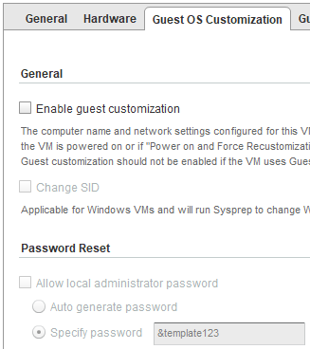

* After disabling all Guest Customisation options leave the VM off and also stop the entire vApp.
* Now add an internet connection via a vShield Edge or WatchGuard FireboxV. You can find the procedures in the next documents (How-To 2 vShield Edge & How-To 3 Watchguard FireboxV).
* Come back to this document when you have finished installing and configuring the firewall.

**AD Finishing**

* Start your firewall and domain controller.
* Log-on to the domain controller and navigate to the folder C:\iNSTALL\
* Right click on “SyncGit.ps1” and choose “Run with PowerShell” to sync with the GitHub repo.

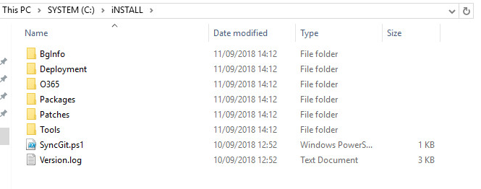

* Now navigate to the folder C:\iNSTALL\deployment\TripleSetup\

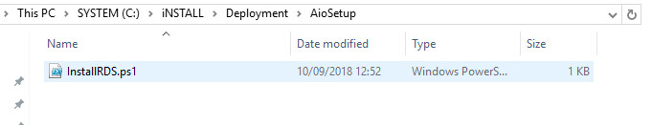

* Run the “CreateCMscript.ps1” script on the server by right clicking on it and choose “Run with PowerShell”.
* It will ask you the relevant questions and then generate all the necessary deployment script files. Two for the domain controller and one for the future RDS server. For the domain name use <customer.cloud>, for example clearmedia.cloud. For the NetBIOS name use only <customer>.
* This will produce 2 scripts for the AD server.
* Run the first script. Thils will reboot the server. Please wait until it has finished.
* Now run the second script.
* Now the AD prep is Finished! Continue with the network settings of the vApp.

**Networking**

* Change the following vApp-net properties:
* Go to the networking tab of the vApp.
* Right-click on the VAppnet and click on “Properties”.
* Go to the “Network-Specification” tab.
* Change the Primary DNS server to “192.168.13.100”, remove the Secondary DNS server and change the DNS suffix to the AD domain name. For example <customer>.cloud.
* Click on OK and then on “Apply” at the bottom.

**Deployment of FS and RDS**

* Deploy 2 extra servers, alongside the existing DC server.
* First, go to the “Virtual Machines” tab.
  + Click on the green “Plus” sign. 
  + Add to extra servers via the “New Virtual Machine wizard”. Use the same template as used for the AD server.
  + Again, do not change any of the Resource values.
  + Name the first server <customer>-FS
  + Name the second server <customer>-RDS

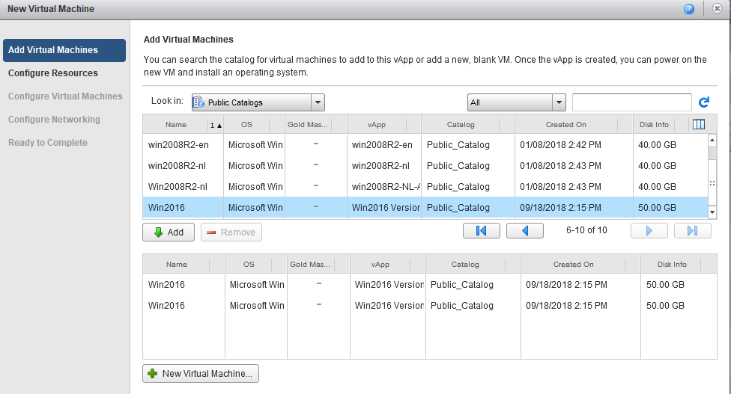

* Expect 20 minutes to deploy the servers.
* Once deployed, configure the required resources via the VM Properties and the Hardware Tab.
* Then go to the Guest OS Customisation Tab.
  + Specify a password under the Password reset field. Use something else then *&template123*
  + Tick the box “Enable this VM to join a domain”.
  + Fill in the required fields. Add the domain admin user credentials and the domain full name you used in the previous steps.

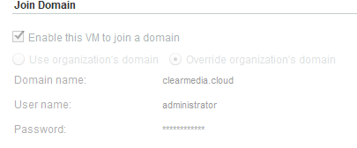

* Power on both machines and wait at least 5 minutes if this is the first time. It should finish with an automatic reboot.
* Return to the Guest Customisation Tab and turn all options off, starting from the bottom and then going up. Do this on both AD, FS and RDS machines.
* Open the vApp Properties and go to the “Starting and Stopping VMs” tab. Change the Stop Action and Start Wait config for the VM’s. All Windows server should be on “Shut Down”. RDS and FS should wait 30 seconds.

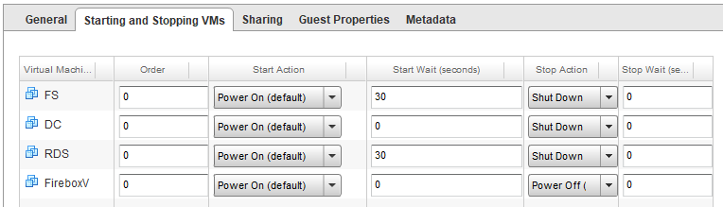

* Boot all servers back up.
* Logon to both servers as the domain administrator.

**RDS Finishing**

* Go back to the AD server, where you can find the script, needed to finish the deployment. It should be the third script that was generated but not yet used. “3_Install_RDS_components.ps1”
* Run this script on the RDS server. After running this script, the server will reboot.
* Logon as domain administrator and run the O365 install script, based on the “How-To 5 O365 deployment” guide.
* Install the F-Secure software, based on the “How-To 6 F-Secure” deployment guide. Use PSB Email and Server Security on the RDS server.
* At the end, request the needed Microsoft Windows Remote Desktop CAL’s from ClearMedia Support. They need to be installed on the AD server as an AD administrator, so make sure the temporary ClearMedia admin account has enough admin rights.
* The RDS server is finished.

**FS Finishing**

* Logon as domain administrator.
* Install the F-Secure software, based on the “How-To 6 F-Secure” deployment guide. Use PSB Server Security (Not Email and Server Security) on the FS server.
* The FS server is finished.

**You’re new triple setup is now finished. It is now up to you for the rest.**